Portable Power for your PI

There are plenty of interesting projects that require your Pi to be untethered from its mains power supply, or require a separate 5V supply that is capable of providing more power than is available from the Pi’s GPIO pins – here’s one way to do this.

The main requirement is to provide suitable regulation at 5V, with sufficient current capacity for your project. Although I initially looked at the cheap and popular 7805 regulator, I rejected it because it’s not very efficient – a major consideration for a battery-powered supply – and it’s only capable of handling 1 Amp – as the Pi uses up to 700mA, that doesn’t leave much spare for driving anything else.

I eventually settled for the LM2576T-5.0 switching step-down voltage regulator – this device is much more efficient than the 7805, and is capable of handling up to 3 Amps. It will take any input voltage from 7 – 40V DC, giving you a wide choice of battery pack - I’m using 8 x 1.2v NiMH batteries, which give a 9.6V supply voltage, but you could use a 12v lead-acid battery if that was more suitable for you. Apart from the regulator chip itself, only 4 other components are needed – 2 capacitors, a choke and a Shottky diode. Here are the RS part numbers:

1 x LM2576T-5.0 460-477

1 x 100uF 25v electrolytic capacitor 684-1942

1 x 1000uf 25v electrolytic capacitor 684-1951

1 x 100uH choke (NB – min 3A current handling) 228-416

1 x Shottky Diode 40V 3A 714-6819

The data sheet for the regulator is here <http://docs-europe.electrocomponents.com/webdocs/0b13/0900766b80b13848.pdf>

where you will also find the circuit details – I’m not going to give any construction details, this is something you should be able to figure out for yourself.

The circuit is easily built on a piece of stripboard; an indicator LED can be added – use a 200 ohm series resistor - and I would recommend 3.25A fuses in series with the positive input and output.

Take care to get the 2 capacitors and the diode the right way round. This is what mine looks like :

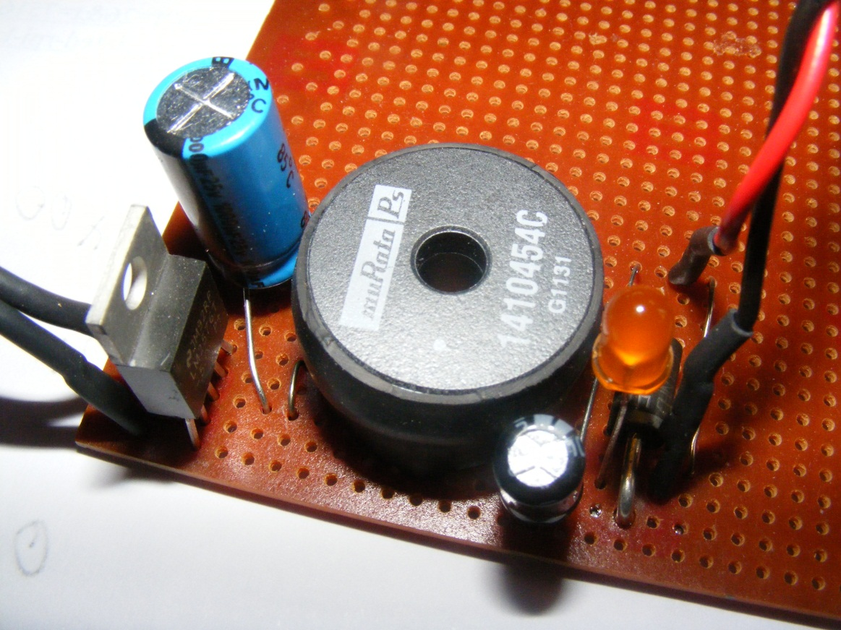

After you have built and tested the supply, if you are going to connect it directly to the Pi, it should be connected via the 2 points marked TP1 and TP2, with the positive feed going to TP1. Don’t try to connect it via the micro-usb socket, as you will then have two 5v voltage regulators trying to do the same job, not a good idea; also, don’t try to connect a mains supply at the same time!

Depending on how much load you put on it, the regulator chip may get warm – if it’s getting hot, a heatsink should be added – there are plenty to choose from, just search on TO-220 heatsink. Note that the metal tab on the regulator is connected to ground / pin 3, so either isolate the heat-sink (most are supplied with a suitable insulating kit) or keep it away from any contact with the other parts of the circuit.